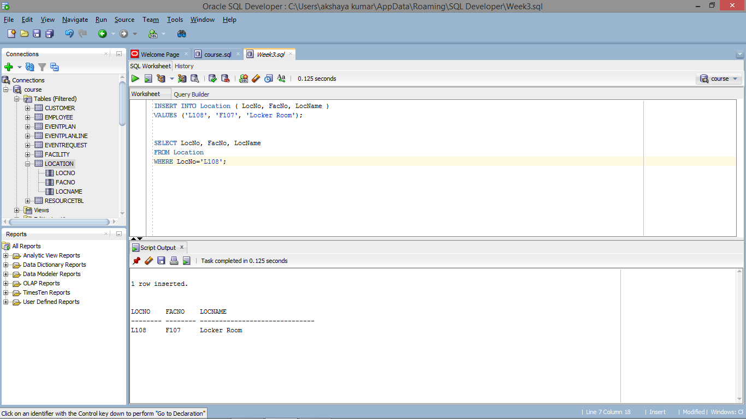

INSERT INTO Location ( LocNo, FacNo, LocName )

VALUES ('L108', 'F107', 'Locker Room');

SELECT LocNo, FacNo, LocName

FROM Location

WHERE LocNo='L108';